APT
# Source: AI Source: Provided by: [Data Path: Persons Table -> ID Column: 1, Name_En Column: Motasem Essam] -> From: [ChatGPT] on [1/26/2026]
APT stands for Advanced Package Tool.
It is the package manager used on Debian-based Linux distributions like Ubuntu, Debian, Linux Mint, etc.

Key Points
# Source: AI Source: Provided by: [Data Path: Persons Table -> ID Column: 1, Name_En Column: Motasem Essam] -> From: [ChatGPT] on [1/26/2026]
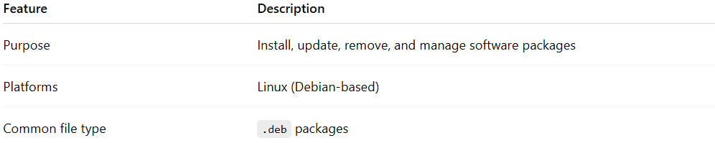
Feature | Description
Purpose | Install, update, remove, and manage software packages
Platforms | Linux (Debian-based)
Common file type | .deb packages

Common Commands
# Source: AI Source: Provided by: [Data Path: Persons Table -> ID Column: 1, Name_En Column: Motasem Essam] -> From: [ChatGPT] on [1/26/2026]
- Update package list
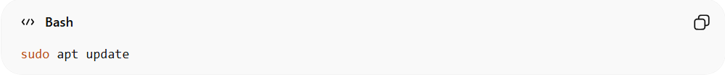
sudo apt update
- Refreshes the list of available packages from repositories.
- Install a package
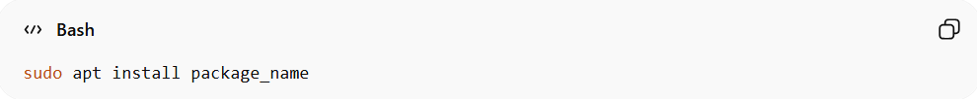
sudo apt install package_name
- Installs a software package.
Example:
sudo apt install git
- Remove a package
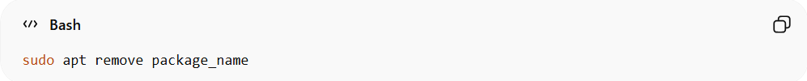
sudo apt remove package_name
- Uninstalls the package but keeps configuration files.
- Upgrade installed packages
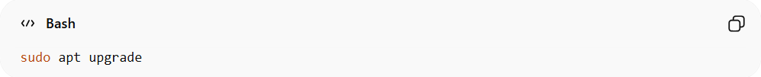
sudo apt upgrade
- Updates all installed packages to the latest version.

✅ Summary:
# Source: AI Source: Provided by: [Data Path: Persons Table -> ID Column: 1, Name_En Column: Motasem Essam] -> From: [ChatGPT] on [1/26/2026]
APT is Linux’s equivalent of pip or npm, but it manages system-level software, not just language-specific libraries.
On Windows, you won’t use APT — it’s specific to Linux.

